7/5/25, 4:31 PM Wednesday in America | # **Numbering Our Days and Limiting Our Words** | Facebook


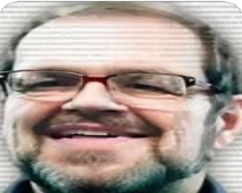
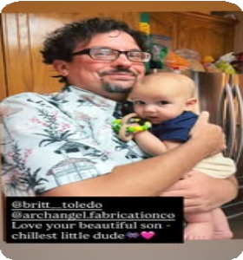


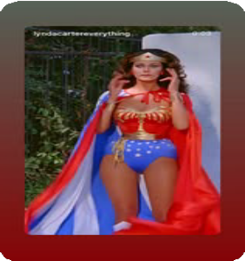


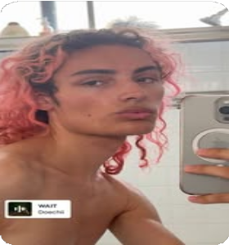





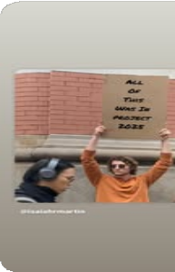



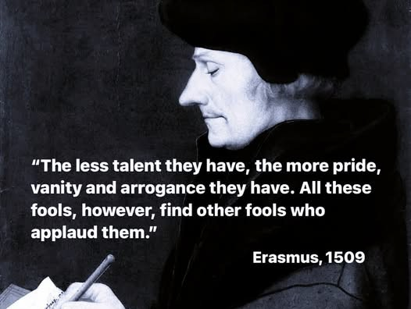


















Tom Sims's post

Wednesday in America
What's on your mind, Tom?

Live video Photo/video Reel

Create story

Structuring Sentences for Dummies
Rob Spicer · Yesterday at 5:16 AM ·

Tom Sims ·
Admin Top contributor
· July 5, 2024 ·

Numbering Our Days and Limiting Our Words
"Teach us to count our days that we may gain a wise heart." - Psalm 90:12
I really need this prayer to be my prayer daily.
I need it to inform everything about how I make decisions and how I communicate as well as how I try to influence others.
You cannot accomplish this for me,. God can. I am working on something inside my soul.
That is where most of the work in my life needs to be done. As an example:
After prayer, but a rather short prayer, I removed one of my own posts because it was attracting the potential for the very sort of conversation that I was advocating the avoidance of.
I was made aware of that by the specific words of a participant and took them to heart.
It was up for an adequate time to be read by all who would read it and it benefited a few folks, I am told, on both sides of the political spectrum.
That was its intent.
It also provoked some helpful comments in the style of point and counterpoint.
So I went silent. I took it down because the discussion went sideways and was tempting me to step beyond the parameters where I felt led to remain in that context.
I hear a lot of: "God told me" kind of talk in the world and among some popular preachers with large, loyal followings. It always makes me charitably suspicious,
I am careful to avoid claims of divine inspiration for my words. It is for me to meet God over that matter and it is for the hearer to determine if my words bring a message from God to them.
None of my words are scripture.
Yet, in my own silence on what might seem to be clear-cut issues, I feel a bit of guilt for not taking a counter-position in the quest for truth,
When we believe we have a perspective that needs to be considered, do we always share it? Do we share it selectively with those we believe will attempt to see it?
Do we simply focus on those who can hear?

Comment as Tom Sims

https://www.facebook.com/groups/wednesdayinamerica/posts/1876983742776264/ 1/1

